Introduction
Recent lock-down measures are being relaxed by the UK Government. As such Bredon School will continue to meet its core objective, which is to ensure the health, safety and wellbeing of all stakeholders. This COVID-19 risk assessment is dynamic and is led by government advice. The latest advice can be obtained from the following government website:
https://www.gov.uk/government/collections/coronavirus-covid-19-guidance-for-schools-and-other-educational-settings
Educational settings are at the forefront of political debate and Bredon has invited age groups back to school in line with the latest advice. Bredon has also remained open for key workers, where it is practical to receive the pupils back into school.
All schools are required to carry out a risk assessment directly addressing risks associated with COVID-19 and operating safely. This is a wide-ranging assessment of operating, which considers all aspects of school life, from parking, social distancing, hygiene, catering, movement around the site, etc. etc. The Government also expects that businesses with more than 50 employees publish the COVID-19 risk assessment on their website. However, there is no requirement to publish any existing risk assessments that do not directly address risks associated with COVID-19.

Risk Management Framework
Bredon School is a community and as such has a duty of care for staff, parents, pupils and visitors. As with any risk, Bredon has a legal obligation to ensure that all stakeholders are, as far a possible protected from harm. COVID-19 has of course to be mitigated as with any other risk. Risk, in some instances can be removed completely. In other instances, it can be reduced or mitigated. However, it is not reasonable or practical to remove all risk, all of the time.
For COVID-19 there are three important factors to take into account:
- State of knowledge – having a knowledge of the pandemic, using the latest government advice.
- Seriousness of likely harm – this will have to be assessed on a case by case basis. A proportionate risk assessment would also have to be taken to identify where the affected individual has been, with whom they had contact and areas they have used. All staff should have completed the Bredon School COVID-19 Risk Assessment - Return to Work Form and an individual Risk Assessment Form.
- Practicality, difficulty and cost of taking precautionary measures – mitigation of risk has to be considered alongside, practicality, cost and the perceived benefit of implementing such a measure;
The following diagram is a useful summary of which type of intervention should be considered first, based on effectiveness and practicality (source: https://www.hse.gov.uk/):
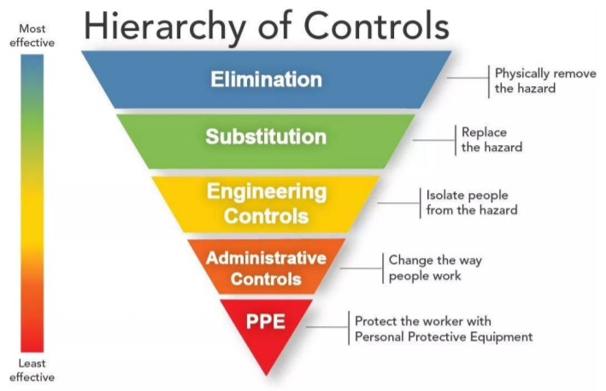

The hazard (COVID-19) is not possible to eliminate. Therefore, we must try to mitigate the risk by imposing Engineering Controls (physical barriers, segregation) and Administrative Controls (training, procedures, checklists) at the forefront of our strategy. Where this cannot be reduced to an acceptable standard, PPE Control will then be considered.
Overall Risk Assessment in the COVID-19 Environment
 | Hazard | Control Measures | Updates
A | Government Advice is not applied correctly/ being followed | Daily briefings received from Cavendish Governors, Professional Bodies (BSA, SoH, ISBA, etc.) | Latest advice taken to include face coverings  https://www.gov.uk/government/publications/actions-for-schools-during-the-coronavirus-outbreak/guidance-for-full-opening-schools o99
B | Communications to stakeholders are not regularly provided | Risk Assessments are dynamic and reviewed frequently. Any fundamental changes are communicated to relevant staff.  Nb Staff operating from home in most instances, so are unaffected by most changes. | Boarding update issued to parents on 04/08/20  Headmasters communication issued to all parents and staff w/c 31/08/20  Transport COVID rules sent 07/09/20
C | Hygiene and social distancing rules are not adhered to in school | Visible reminders (signs, 2m distancing tape).  Parents and staff have been informed of what is expected of them (return to work process/ unfurlough process).  Supervision of pupils to ensure that they are verbally reminded of SD  Bubbles are kept separate to limit the exposure to others.  Catering is substituted with shop bought sandwiches and items that do not need to be ‘handled’.  Additional Cleaning (see later) | Junior School to operate in bubble  Senior School will operate in year group bubbles  Transport routes will be a bubble, with rules sent and displayed in buses  Assessment given to COVID-19 case and close contact considered  Communications to staff in INSET and at briefings to remind pupils to use sinks  Catering to return in September – separate workstream to promote SD and provide “grab and go” options, cleaning regime, etc  Fogging of classrooms in break and lunch, use of Zoono product and ionised water (all of which kill COVID)
D | Supplies of hand soap/ hand santiser | Stock levels are maintained by bursary, via the accommodation services team. | Installation of new hand basins along high traffic areas and near entrances to encourage handwashing  Various hand sanitising stations throughout the building, clearly labelled  Hand sanitisers are also located where pupils alight and embark school transport (sanitiser is supplied on transport also)
E | Unsuitable cleaning regime in school | Dedicated Accommodation Services team, rotating around classrooms and common areas. Particular focus on regular touch points & where possible these are eliminated (such as the opening of non-fire doors).  Maintenance of cleaning team suitable for areas to ensure multiple cleans | Fogging cleaning carried out at Break and lunchtimes. These kill COVID on contact.  Teachers to clean desks and equipment between use, using ionised water (which kills COVID)  Touch points cleaned with specialised product that provides 21 days protection (Zoono)
G | The transfer of infection with the use of shared equipment | Pupils are asked to bring their own stationery and Chrome Books, etc. Where the likelihood of sharing is unavoidable, regular cleaning is performed. | Teachers to clean shared equipment when use is unavoidable.  Pupils to use only their own stationery and bring their own water bottles into school  Parents have been asked for pupils to BYOD where possible to reduce multi use.
H | Regular appraisal of Hazards & mitigates via suitable forum | Discussed at SMT – no quorum for regular H&S meeting, so SMT has now become main discussion and sign of for COVID-19 related issues | Last SMT 03/08/20  Workstreams led by Bursar for:  i) classroom environment;  ii) catering,  iii) boarding;  iv) transport;  v) site  to feed into overall RA & comms to parents  Regular H&S meetings now scheduled for start of term.

Pupil, Parents & Staff Risk Assessments
 | Hazard | Control Measures | Updates
A | Staff attending site are at risk of infecting/ being infected with COVID-19 | All staff are required to complete a Return to Work Form with Bursary.  All Staff have been asked to complete an Individual Risk Assessment to ascertain the risk profile of staff | All visitors use the Test & Trace sign in log (Both Bursary and reception)  Any non-Bredon member of staff (Peripatetic/ contractor, etc.) are required to wear face masks onsite. These can be removed once in the classroom, provided 2m SD can be applied.
B | Pupils are at risk of infecting/ being infected | Over & above the normal routines, parents have been communicated the protocol of bring their child onsite.  Regimented entry to school, using different entrances  Temperature checks are performed each week (not daily). | Refer to parents and staff update
C | Staff training is inadequate on COVID-19 (symptoms, handwashing) | Staff have been given access to training videos, via Staff update COVID-19.  Pupil exhibiting symptoms will be sent home to follow test and trace programme & areas of school deep cleaned. | Action to consider and send this or issue the RA instead  Inset day training  Any changes are conveyed during staff briefings
D | Test & Trace Programme | Refer to the above communication | School Nurses are leading the Test & Trace within Bredon School
E | Start & end of School – procedures not in place/ followed | Different age groups have different entrances, manned by staff with hand sanitiser. SD applies at all times. Led to classrooms that are market out with SD measures. | Staff are to meet with pupils and all are to SD and congregate on the new Astro (first day)  All pupils make their way to tutor groups.  SD, floor markings are highly around areas of school with high volume of pupil traffic.
F | Restricted areas, e.g. corridors, car parks | Where possible one-way systems operate. Where this is not possible, SD rules and hygiene emphasised (notices).  Pupils are told to avoid cross-over where possible. | Identify particular “pinch points”  Clearly mark floors (directional signage)  Signage (one-way and SD in abundance in corridors)  Optional use of facemasks in communal area being considered in line with government advice  Of 221 pupils, 96 board and 80 come in by day bus. Therefore very limited parent drop off and mainly junior school (limited car park use)
G | Configuration of classrooms are not compliant to SD rules | All classrooms have tape on floors to position desks and to encourage SD. Only 1 pupil per desk. Space is not an issue at Bredon. | Monitor latest government advice  No face covering in class, unless want to  Face shields will be made available to teaching staff  Forward-facing desks  Flexi-use of largest classrooms within departments
H | External space enables mixing of ‘Bubbles’ | Separate play areas, cordoned off with rope and fully supervised.  Number of pupils are low, making this relatively easy to enforce. | Separate (supervised) snack stations to reduce bubbles mixing  Staggered lunch and break times
I | Internal space enables mixing of Bubbles | Separate areas of the school are used for different Bubbles, eliminating cross-over of Bubbles. | Staggered lunch to reduce lunchtime  One way systems and SD to minimise close contact
J | Medical Area/ behavioural areas not sufficient | No medical bay  Small numbers make behavioural issues easy to deal with. Two staff members per Pod also. | Medical bay moved to SMART building with 7 sick rooms.  One-way system in operation
K | DSL/ Safeguarding access not available | DSL on site at all times whilst pupils are on site  Safeguarding Lead always on site
L | Fire Drills/ Evacuation Procedure | No changes – ability to exit building in orderly fashion and meet at normal evacuation point in Bubbles | Fire drill takes priority over COVID-19.  Normal area on astro
M | Use of play/ outdoor activity equipment | No play equipment is used (climbing/ swimming pool, etc) | Play equipment to be cleaned with Zoono product (21 day cover)  Swimming pool use is
N | Catering facilities – control of COVID-19 | No catering offered onsite, only packed lunches brought in, or purchased from a supermarket. Food handling is kept to external packaging only and normal hand washing applies. | Return to school will see use of three dining rooms (Dining, conference and Old Library). Juniors are to eat at 12 midday in Old Library, after which it is cleaned. All dining areas are cleaned with Zoono 21 day cover, as well as normal cleaning of tables.  Marquee and benches are used to bring external space into play.  Face shields and gloves to be used by catering staff.  “Grab and go”/ easy to serve foods will be on offer (no help yourself options).
O | Use of ablution facilities | Designated toilet areas for ‘Bubbles’ to use (Male and female). These are regularly cleaned. | Additional cleaning of stable house toilets that also double as boarding toilets
P | Staff meetings/ gatherings | Online where possible, otherwise SD applies. | Sportshall used to have briefings with exam desks SD and cleaned regularly

Medical Risk Assessment
 | Hazard | Control Measures | Updates
 | Insufficient Staffing | Nurses available First Aid trained staff on site identified  Welfare staff assigned on site | Two part time nurses employed with hand over period
 | Medical room not properly equipped | Medical room is not currently being used | See above update of new medical area
 | Inadequate PPE/ training | Current government advice is that PPE is not required in schools for staff or pupils. | Catering staff, returning in August are to use Face Shields (11/8)  Abundant availability of face masks and face shields
 | Medical PPE | N/A - No medical staff currently on site | Medical staff to use face mask
 | Staff attending site are at risk of infecting/ being infected with COVID-19 | All staff are required to complete a Return to Work Form with Bursary.  All Staff have been asked to complete an Individual Risk Assessment to ascertain the risk profile of staff | All staff to err on the side of caution and do not come into work if they are experiencing COVID-like symptoms. Must obtain a negative test before returning to work.
 | Procedure to follow if suspected case of COVID-19 | Following government protocol, which was issued in staff update. | Refer to medical update. All day pupils will be isolated and picked up by parent.  Boarding pupil, as above, or isolated in COVID area.  See above point for staff
 | Test & Trace routine unfamiliar | Refer to above staff update | Inset day  Refer to COVID symptoms flowchart
 | Temperature checks | Use of infrared non-contact thermometer | No required from September
 | Welfare & mental health associated with lock-down & non-attendance at school | Use of Teens in Crisis & access to nurse | Re-engaged with Teens in Crisis.  School Nurse with Mental Health qualification, new for September 2020.
 | Clothing | No uniform is worn, encouraging a change of clothes daily. | Pupils to wear normal uniform  Boarding clothing is to be regularly washed in line with day pupils  Games days – pupils are required to wear sport kit all day to reduce changing and help with washing of uniform.  Aprons are required for each pupil – communication to parents prior to start of term  Overalls & Weelies are required for each pupil (Same comms as above)
 | Reporting of accidents/ and suspected cases of COVID-19 | Captured by School Nurse  Suspected COVID-19 cases (2 of) have been tested negative. Separate bubbles of support staff.  Information key to test & trace

Appendices
Test & Trace Protocol
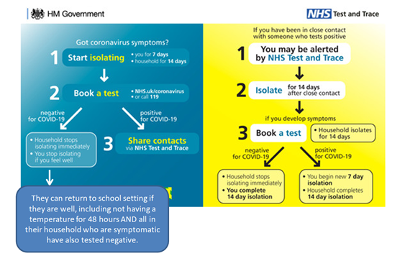
Latest government Advice on COVID-19 https://www.gov.uk/coronavirus
How to wash your hands effectively https://youtu.be/IsgLivAD2FE
How to protect yourself from COVID-19 https://youtu.be/ztj7JhMt3Wc
Recognising the symptoms of COVID-19 https://youtu.be/T8s5z9ZrUdo
Steps to slow the virus down https://youtu.be/1jZoWIWsEU8

